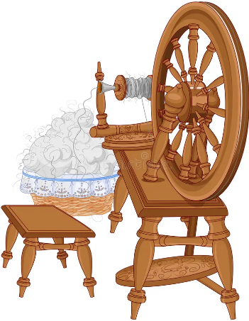**Equipment Re-Employment Center**

Equipment Type: (Loom, wheel, etc.)

_______________________________________________________

_______________________________________________________

Price: ___________________

Your contact information:

Name___________________________________

Phone Number____________________________

Email____________________________________

Equipment Location: (City, State)_______________________________

Has your loom heard rumors of future downsizing?  Do you have a wheel looking for new challenges or opportunities?  Is that drum carder drumming its fingers in boredom?  Find them a new position!  Fill out this form and it will be printed and displayed at KAWS!